# JIF Application User Guide

Contents

JIF Application User Guide 1

Registering for a MAX ID 2

Adding a Concept 5

Concept Paper Details 5

Adding Users to View and Edit Concept 6

Proposal Details 7

Adding Users to View and Edit Proposals 8

Project Plans 8

Analysis of Alternatives (AOA) 10

POAM&M 10

Spend Plan 11

Proposal Review 11

Exporting Proposal 12

## Registering for a MAX ID

To enter a JIF proposal, one will need a MAX ID to do so. If you are a new user to MAX start by logging into www.max.gov. If you have an account that has been deactivated, please contact MAX support (Phone: 202-395-6860 or Email: [maxsupport@max.gov](mailto:maxsupport@max.gov)) to reactivate your account

* Login into [www.max.gov](http://www.max.gov)

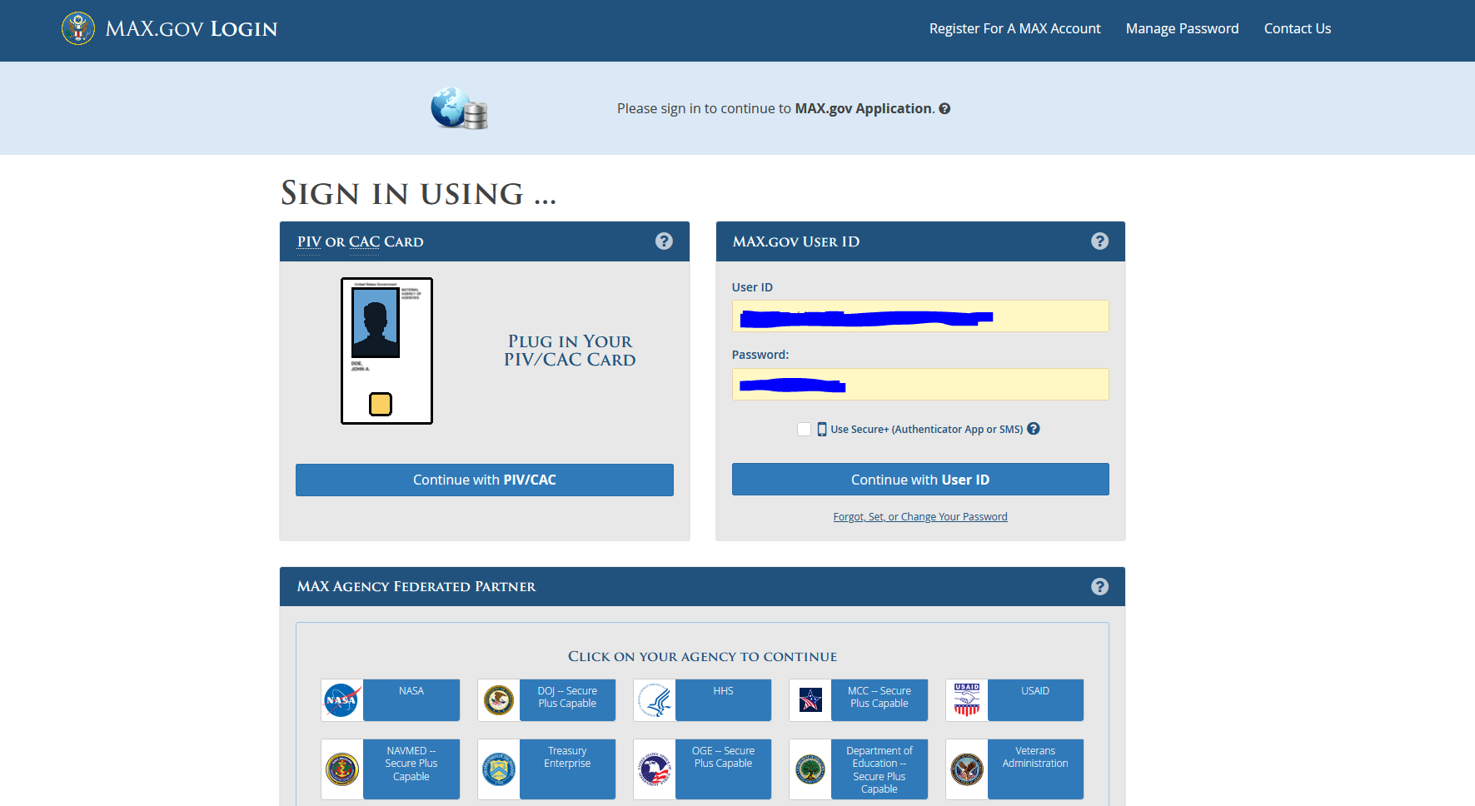

* Select “Register for a MAX Account” from the MAX.gov Login screen.

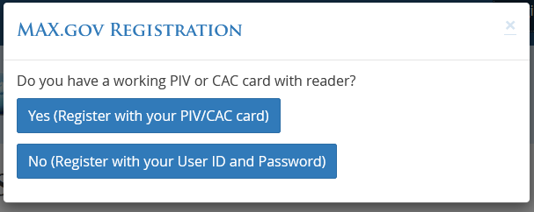

* Select the “Yes” option to register with a PIV or CAC card or select “No” to register with a username and password from the registration dialog box.
* After your selection of “Yes” users will follow the prompts provided to complete the registration for the PIC/CAC card. On the selection of “No” within the MAX.gov Registration dialog users will fill out the form below. 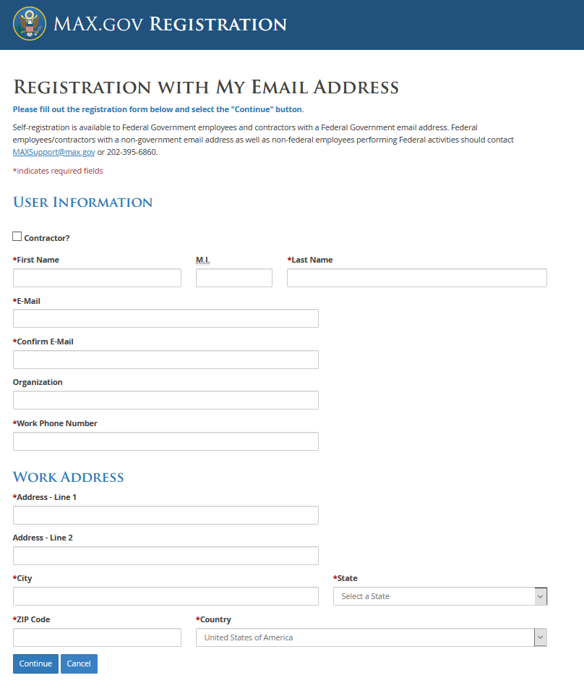
* After user completes the registration process. The user will see the MAX.gov Homepage.

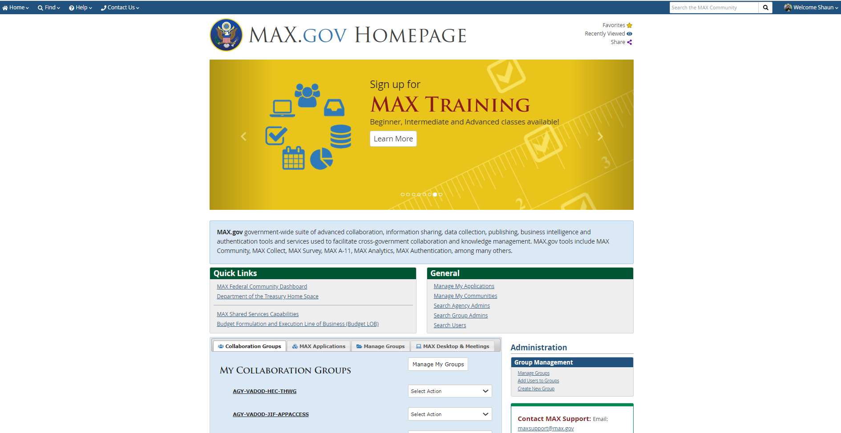

* Use the following link ( https://go.max.gov/jif) to navigate to the Joint Incentive Fund (JIF) homepage.

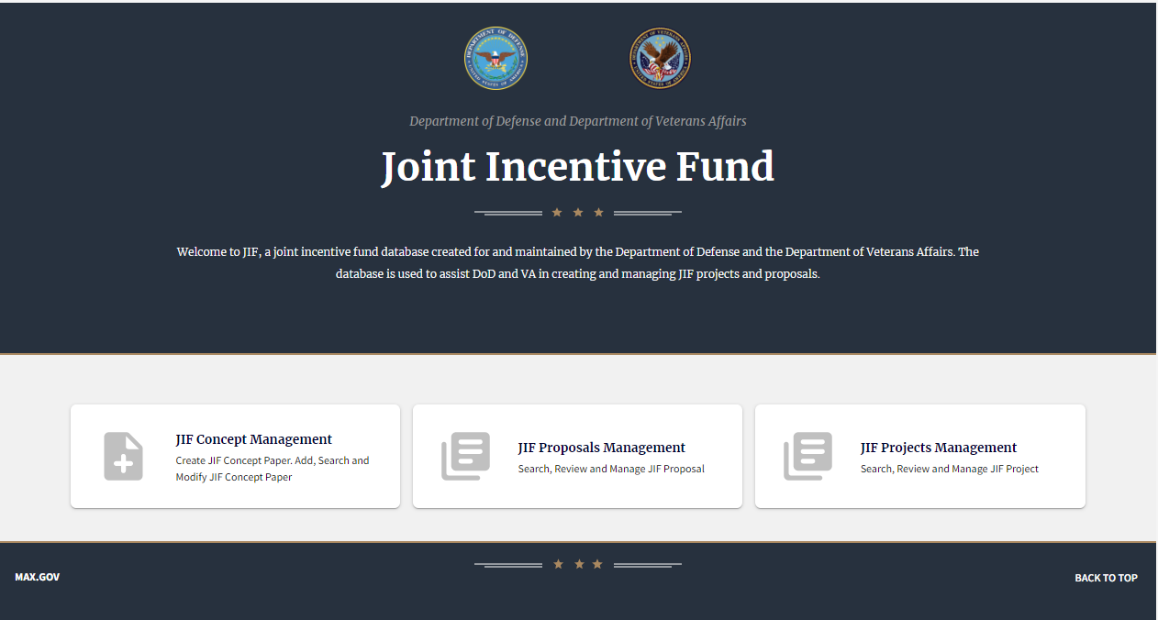

* Select the option for “JIF Concept Management” to add a new concept.

## Adding a Concept

* After the selection of the option “JIF Concept Management”, the select “Add New Concept” to start entering the JIF concept information.
* For additional guidance and reference documentation select the “JIF Tool Box”.

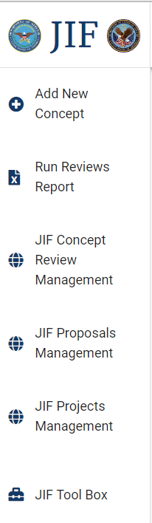

* After the selection of ‘Add New Concept’, select “Next” within the dialog to continue to add the new concept or “Cancel” to close the dialog box.

## Concept Paper Details

* After the selection of “Next”, the new concept paper will display for the end-user. Displaying the ‘Concept Details’ screen and the user will enter the necessary information for the following fields.
  + **Concept Title** – Enter the name of the concept that will be submitted for review
  + **Facility Names DoD and VA** – Enter the DoD and VA facility names associated with the concept
  + **Fiscal Year** – Select the submission year for the concept
  + **DoD POC Information** – Provide the identifying information for the DoD POC for the concept (DoD Facility/Program Office, Name, Title, Phone, Extension, and Email)
  + **VA POC Information** – Provide the identifying information for the VA POC for the concept (VA Facility/Program Office, Name, Title, Phone, Extension, and Email)
  + **Executive Summary** – Provide a short, succinct description of the project including how funds will be spent.
  + **Sustainment Plan** – Describe how sustainment of the project will be funded after all JIF funds have been expended.
  + **Concept Support which corporate priority and/or VA/DoD Joint Strategic Plan Objective** – Provide a detailed description of how the concept will support the JSP objective.
  + **Expected outcomes** - Provide a quantifiable and qualitative metrics that demonstrate the project’s progression.
  + **Potential Challenges –** Describe potential challenges which the project might encounter.
  + **Previous Work –** Describe previous work in this area or linkage to other projects in any.
  + **Financial Cost Estimate –** Provide the allocation of requested for the concept being submitted.
  + **Supporting Documentation-** Attach any supporting documentation.

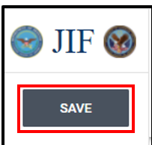

***Note:*** *If the entered data has not been saved the end-user will be notified that the entered data has not been saved before navigating away from the screen.*

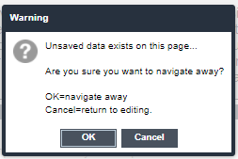

## Adding Users to View and Edit Concept

* Select the plus sign icon (+) in the heading of the ‘Concept Details’ screen.



* End-user will have the ability to add additional end-users to the concept permissions.
* Select “Add Users or Groups” to complete the action or “Cancel” to cancel the action of adding users or groups.

## Proposal Details

After the submission and review of the concept paper, the appropriate parties will be notified of the approval or denial of the submission. If the concept paper is approved, a new proposal will be created and the user will need to complete the following within the ‘Proposal Management’ form.

* + **Geographic Scope** – Select the geographic scope for the proposal (Local, National, or Regional)
  + **DoD Budget Resource Manager** – Provide the identifying information for the DoD Budget Resource Manager (Name, Title, Phone, Extension, and Email)
  + **VA Budget Resource Manager** - Provide the identifying information for the VA Budget Resource Manager (Name, Title, Phone, Extension, and Email)
  + **Expected Results and Assumptions to Justify the Proposal** – Describe how data will be collected throughout the life cycle of the project. Ensure data can be effectively tracked.
  + **Methodology and Data to Achieve Sustainment** – Describe the groups of individuals who will be engaged in the project.
  + **Conditions** – Describe where and when the project will take place.
  + **Results/Findings** – Report the expected outcome(s) of the project. State the findings in a logical sequence without bias, also provide the GME requirements.
  + **Issues** – Provide problem(s)/difficulties that may be encountered during the execution of project activities (e.g., May there be contracting or credentialling delays, etc.?)
  + **Proposal Supporting Documentation** – Provide all project related files (charts, graphs, etc.)
* After all information has been entered within the ‘Proposal Details’ screen select “Save” from the JIF side menu. End-users can save at any time during the process of data entry.

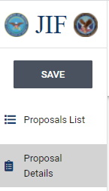

***Note:*** *If the entered data has not been saved the end-user will be notified that the entered data has not been saved before navigating away from the screen.*



## Adding Users to View and Edit Proposals

* Select the plus sign icon (+) in the heading of the ‘Proposal Details’ screen.



* End-user will have the ability to add additional end-users to the proposal permissions.
* Select “Add Users or Groups” to complete the action or “Cancel” to cancel the action of adding users or groups.

## Project Plans

* Select the ‘Project Plans’ tab from the side menu, the project plans screen will display and the following fields for data entry.
  + **Type of Care Provided** – Provide the type of care that the project will provide (e.g., Physical Therapy)
  + **Beneficiaries Seen** – Provide the types of beneficiaries serviced by the project (e.g., TRICARE PRIME, VHA enrollees)
  + **Providing Facilities/Clinics** – Provide the names of the facilities and clinics that will provide the services.
  + **Originating Facilities of Providers** – Provide the name of the parent facility for the provider.
  + **Billing Rate/Costs to be Tracked and Methods of Tracking** – Provide the costs and how the costs will be tracked. Methods of tracking must also be stated.
  + **Sustainment Plan** – Provide a detailed explanation of how sustainment of the project will be funded after all the JIF funding has been expended.

***Project Plan IT/OI&T***

* + **Applicable IT/OI&T Project Plan table** – End-users will provide owners of milestones/tasks, descriptions, Start and End dates of functionality/requirements needed to complete the project. These entries shall include but are not limited to key tasks, milestones, and items for the project critical path.
    - Select “Add Row” from the table tool bar.

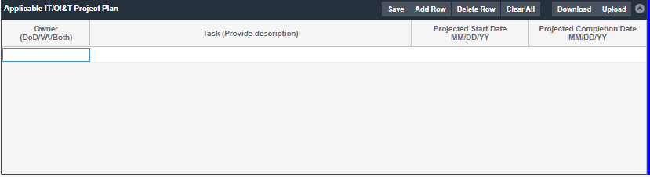

* + - Select the owner of the of the task by selecting from one of the drop-down options (DoD, VA, Both) within the “Owner” column.
    - Provide a description of the task within the “Task” column.
    - Enter or select a projected start date for the task within the “Projected Start Date” column.
    - Enter or select a projected completion date for the task within the “Projected Completion Date” column.

***VA IT/OI&T Task (VA Project Managers must complete the following fields)***

* + **Business Function Alignment** – Provide a list of approved business functions that the identified functionality of the solution must support.
  + **In Scope** – Provide the functionality/requirements needed to complete the request and create value. Document specific details about the desired changes or new functionality being requested and the requirements needed to fulfill the request.
  + **Out of Scope**- Identify capabilities that are not needed/required for this effort. Identify functionality that may be “Nice to Haves”, but is not necessary for the project.
  + **Non-Functional Requirements** – Provide the applicable office of information and technology compliance epics that need to be incorporated to meet the needs of the project.
    - *Repository ID: NONE requirement*
    - *Add Security Review Rating for the epic. These can be found at* [*https://vaww.vha.esp.va.gov/sites/RDM/internal%202/RDMGoalsFY15/Shared%20Documents/Security%20Review%20Rating%20for%20Epics.docx*](https://vaww.vha.esp.va.gov/sites/RDM/internal%202/RDMGoalsFY15/Shared%20Documents/Security%20Review%20Rating%20for%20Epics.docx)
    - *Describe the characteristics or quality attributes of the system (e.g., related to availability, capacity, efficiency, interoperability, performance, security, testability, maintainability, monitor ability, portability, reliability, and usability.*
    - *Applicable OI&T Compliance Epics should be incorporated to meet the needs of the project.*
    - *Additional OI&T Compliance Epics should be reviewed*
  + **Critical Success Factors** – Provide the Critical Success Factors (CSF) of the epic, the key areas where an organization must perform well on a consistent basis to achieve its mission. CSFs are outcomes that the project wants to achieve that are associated with strategic goals and objectives.
  + **Key Results Indicators (KRI)** – Describe the results that could be obtained for each CSF according to one or more of the six outcome perspectives (Mission Essential Function, Process Improvement, Financial, Learning & Growth, Veteran Satisfaction, Employee Satisfaction). These are a “measure of the results from the business actions which are critical in tracking progress and defining success. Identify a measure of the results in each of the “Outcome Perspectives” categories that would validate the implementation was complete and successful. Describe the measure of success in SMART terms: Specific, Measurable, Achievable, Relevant, and Timely. (THIS EXERCISE MUST BE COMPLTED FOR EACH CSF)
* After all information has been entered within the ‘Project Plans’ screen select “Save” from the JIF side menu. End-users can save at any time during the process of data entry.

## Analysis of Alternatives (AOA)

* Select the “Analysis of Alternatives” tab from the side menu, the analysis of alternative screen will display and the following fields for data entry.
  + Alternative Solution Considered – Provide the various/different alternatives that were explored for the project.
  + Disadvantages – State the disadvantages associated with the other considered solution.
  + Technology – Describe the technology to be used within
  + Cost Resources – Provide a summary of how the funding will be utilized by each partner. Include details, contract costs, inflation, and salaries.
  + Timeline – Provide a timeline of the project steps and progress. Details will need to be included.
* After all information has been entered within the ‘Analysis of Alternatives’ screen select “Save” from the JIF side menu. End-users can save at any time during the process of data entry.

## POAM&M

* Select the “POAM&M” tab from the side menu and fill out the fields as stated below.
  + **S.M.A.R.T Goals** – Provide a detailed statement/criteria of the initiatives/goals are specific, measurable, achievable, realistic, and time bound (includes a timeline). Ensuring the defined objectives are defined and attainable within a certain timeframe of 2 years.
  + **Impact Statement** – Provide one or two sentences that describe the direct result(s) of the project. What is the problem you are solving?
  + **Activities/Milestones** – Provide the “to do” to list and describe the activities/SMART goals of the project.
  + **Measure/Metric** – Provide the metrics that will show the progress of the project. Provide the M2 query used to gather the data, also include a readiness metric.
* After all information has been entered within the ‘POAM&M’ screen select “Save” from the JIF side menu. End-users can save at any time during the process of data entry.

## Spend Plan

* Select the “Spend Plan” tab from the side menu, the spend plan screen will display and the following grids/tables for data entry.
  + **DoD Capital and Operating Expense Plan** – Enter the planned quarterly allocation of requested funding for CAPEX and OPEX.
  + **VA Capital and Operating Expense Plan** – Enter the planned quarterly allocation of requested funding for CAPEX and OPEX.
    - End user(s) will select a cell for the appropriate cell and enter a numeric value.
      * The entry will display within the cell and also calculate within the ‘Total Cost Plan’ table.
    - If the user needs to add a row to the table because the CAPEX or OPEX category does not exist. The user will use the following steps:
      * Place the mouse in the place where the row is needed within the table.
      * Right-Click within the table.
      * Select “Add Row”
      * Enter the name for the row and provide the numeric values within the associated column(s).

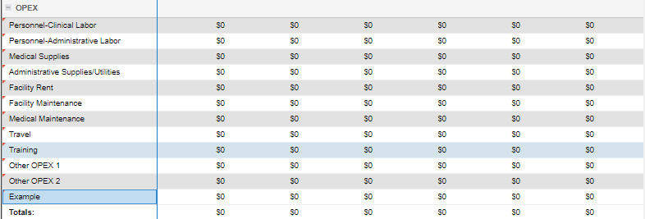

* After all information has been entered within the ‘POAM&M’ screen select “Save” from the JIF side menu. End-users can save at any time during the process of data entry.

## Proposal Review

* Select the “Proposal Review” tab from the side menu, the spend plan screen will display and the following tables and fields for data entry.
  + **Review of Proposal by Stakeholders Relevant to the Proposal** – Provide the names and contact information for the DoD and VA stakeholders that will need to review or are associated with the proposal.
  + **JIF Approval** – The signature authorities for the proposal will enter their title and digital signature by selecting the sign button associated with their corresponding title.
    - The URL for the proposal will need to be sent to the individuals responsible for the signing the proposal.
    - After all signatures are collected, the DoD and VA Project Managers will have the ability to submit the proposal for review, by selecting the “Submit” button on the side menu.



***Note:*** *If the stakeholders and approval authority have not been added to the permission for the proposal, navigate to the ‘Proposal Details’ screen and add them to the proposal permissions by following the steps below.*

* + Navigate to the ‘Proposal Details’ screen
  + Select the plus sign icon (+) in the heading of the ‘Proposal Details’ screen.



* + Project Managers will have the ability to add additional end-users to the proposal permissions.
  + Select “Add Users or Groups” to complete the action or “Cancel” to cancel the action of adding users or groups

## Exporting Proposal

* Select the “Export Proposal to PDF” from the side menu, the proposal document will display within PDF format. (User(s) can perform this action any time throughout the process.). DoD project Managers should then save the proposal to their PC so they can then enter it into the MHS Portal as required.